Donate a Car Canada FAQs

How, and by whom, is vehicle value established?

We have two possible sale procedures that help us to maximize the highest donation amount possible for the charities: auto recycling and auctioning. Donors are thoroughly advised of these options and details.

If a vehicle is selected for our recycle process, the donation amount for a recycled vehicle is dependent on the area in which it is located, and what the market will pay for the year/make/model at the time. The vehicle will be picked up by our towing agent at no cost to the donor. Towing is included for all recycled vehicles.

Alternatively, we can process a vehicle through our auction and re-sale agents. There are many factors that go into qualifying a vehicle for sale by auction/re-sale. These include, but are not limited to, drivability, mechanical condition, age, damage, visual appearance, and odometer reading.

All vehicles sold at auction are sold with an “as is” and “unreserved” (sold to the highest bidder) status. This ensures the sale is final, and protects the donor from having to provide a warranty to the buyer. Processing costs are deducted from the sale price. These costs may include lien searches, towing, gas, cleaning, auction fees, and administrative fees. After these deductions are applied, the net sale amount is processed through CanadaHelps, and sent to your charity. CanadaHelps then sends a tax receipt to the vehicle owner for that amount.

Please note that the Kelly Blue Book and its competitor, the Black Book, are not typically reliable sources in determining value for donated vehicles. We rely on our agents to provide us current market information in determining best process on a vehicle-by-vehicle basis.

Is there a minimum donation outcome?

While auction outcomes can be unpredictable (providing a range of donations from just a few dollars up to thousands of dollars) and the metal market can fluctuate, we ensure that our donors are aware of the current minimum donation amount at the time of their donation. Their individual outcome is determined by many variables, including the current market price, size/age/model and mileage on the vehicle, and their location. (Please see subsequent FAQ answers for more explanation on this.)

Does Donate-a-Car remove any administration charges/fees?

DAC admin fees range from 0% to 15% of the final sale outcome on re-sale vehicles. Our fees on recycle-ready vehicles also fluctuate, and are dependent on shifts in the market. We are subject to what regional agents are able to afford to pay out as a flat rate at any given time. We are in ongoing communication with our recycle agents, ensuring that they are offering top dollar (after their own costs are removed), and we quickly adapt our own fees with each fluctuation in the market. Because Donate a Car Canada is a business and not a non-profit, our fees enable us to continue the work of facilitating the vehicle donation process on behalf of donors and charities alike.

How is the vehicle title/ownership managed?

The transfer of ownership begins when the donor signs the back of the official vehicle registration. Our agents complete the process on behalf of our donors. It is completed when the vehicle sells.

Why do you not provide a $300.00 minimum donation (like the Kidney Foundation)?

Through our program, you are going to receive a monetary gift that reflects the value of the donor’s vehicle in any given market. If you receive a gift of $1,000.00 you can be assured that was the value of the vehicle at the time of sale (less costs). When the market is strong, recycling yards may be able to pay several hundred dollars for a vehicle. When the market is hurting the amount per vehicle will drop to reflect what the yard actually paid out for the vehicle.

This is important to you as the charity because you want to ensure that the tax receipt is directly reflecting the value of the gift that you received.

There is one especially significant difference between Donate a Car Canada and other programs, such as the Kidney Foundation Kidney Car program. You may have noticed that they offer a flat donation rate of $300.00 per vehicle? As a charity, a gift of a vehicle would allow the receiving organization to receipt on the charities appraised fair market value of that car, less the advantages. As a company, we must receipt on the actual net value of the vehicle after all expenses have been paid. You, as a charity, receive the gift as a cash donation (without the worrisome effort of processing a gift in kind), and Canada Helps is then only able to receipt on that net amount.

Our recycle agents pay us the value of the vehicle after they deduct their towing fees and labor costs to dispose of the vehicle. This value fluctuates continually. When prices are high, we can see returns of hundreds, or thousands, of dollars. When prices hit their lowest, we saw the price of metal hit $20.00/ton. That translated into a vehicle value of less than $50.00 to the agent (meaning, recyclers had to pay us out of pocket as they were not making any profit on some vehicles). It is for this reason that we cannot offer a static minimum amount on recycle-ready vehicles.

How does my charity receive funds through this donation process?

The funds will be disbursed to you directly from CanadaHelps. If you already have an account with them, your funds will be directly deposited into your bank account. If you do not, they will mail you a cheque for all donations received through us. Please note that we will not share your banking information with them, so you will need to set that up directly with them if you have not already done so. Once you have received the funds, CanadaHelps will issue and distribute the tax receipts directly to all your donors.

How can my charity benefit the most from this partnership?

By letting your donors know that you accept vehicle donations. Competition for this source of income is increasing, so you’ll want to make sure you don’t get left behind. Our program also offers your charity custom advertising materials. Our goal is to make promoting your vehicle donation program easy! Login to your account to see your custom flyers, posters, and all premade social media posts. Joining the discussion and commenting on our social media posts can also help bring traffic your way from our page as well!

My donor is confused about why CanadaHelps is sending the tax receipt (instead of Donate a Car sending the receipt directly). How can I explain this to my donor?

The role of Donate a Car Canada is to act as an agent on the charity’s behalf. Receiving Gifts in Kind (particularly of the magnitude of a donated vehicle) would be cost prohibitive and require significant program development on the charity’s part. Donate a Car Canada takes care of all the particulars for this kind of donation, and we have partnered with CanadaHelps for receipting so that the charity can spend those efforts (and funds) elsewhere, too. Donate a Car Canada is a business, not a not-for-profit organization, and our conservative budget ensures that we are able to continue to serve our charities in providing these extensive services.

How does Donate a Car Canada keep our donor informed of their process?

Our team of personally engaged and caring team members works diligently to ensure that donors have access to support and detailed information about their vehicle donation at every turn. If a donor reaches out to you for clarity about some aspect of their process with us, please direct them back to our toll-free number (1-877-250-4904) and we will promptly respond to them directly.

For your own detailed understanding, here are some of the key pieces of information we provide:

- A drop-down list when they submit their vehicle, noting the specifics about the difference between a “recycle” ready vehicle and an “auction” vehicle. Here are some visuals that will show you what our donors see when they’re filling in their donation submission form:

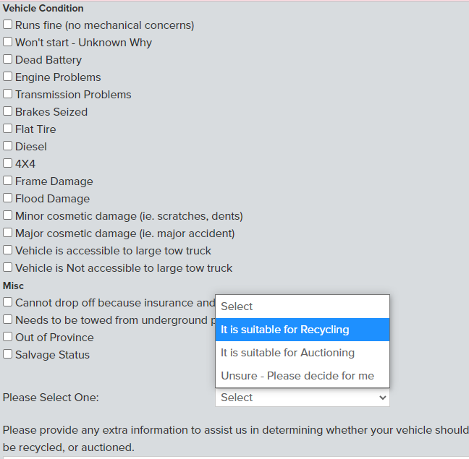
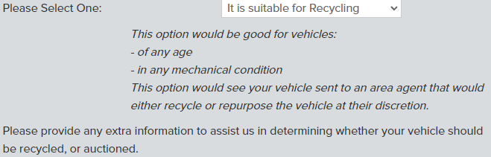

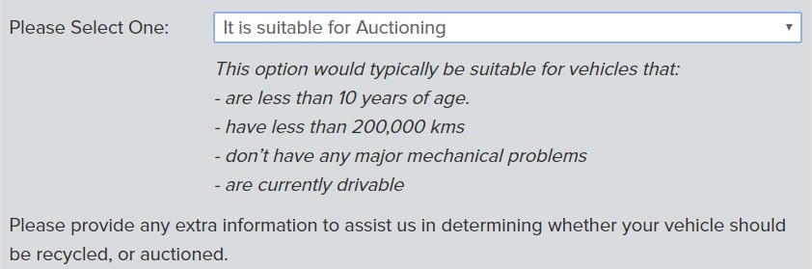

- An email that outlines the recycle, or auction, process, depending on what is applied to their vehicle. This is typically sent within two hours of their submission being completed.
- Contact information for their supporting recycle agent and our own contact information for both email and telephone communications. We also double-check donor contact information to ensure that they are able to receive email. If they are not, we ensure that they are provided all particulars over the phone.
- A link to our Metal Monster blog post, explaining in detail why the market is up or down.
- Follow-up emails to indicate when their gift is in the accounting process, and when their gift has been disbursed to your charity.

My question isn’t answered here – who can I talk to about this?

You are always welcome to call our toll-free line (1-877-250-4904), and our charities coordinator will be happy to help. You can also reach us at charitycare@donatecar.ca.

